Client Report: 4-Day Meeting Summary

**Client Name:** Naresh

**Project:** Medication Recommendation System.

**Prepared By:** A. Saikrishna

# Day 1: Meeting with Chemist



**Objective:**

The primary objective of this meeting was to gather insights about medication prescriptions, common drug interactions, and over-the-counter medicine trends to enhance the Medication Recommendation System.

# Questions Discussed:

1. What are the most commonly prescribed medications for chronic conditions?
2. How do you determine the correct dosage for a patient?
3. How do you handle cases where patients have multiple prescriptions?
4. Are there common drug interactions that we should be aware of?
5. What precautions should be taken when recommending medications based on symptoms?
6. How often do you suggest over-the-counter alternatives to patients?
7. What are some of the challenges in advising patients on medication adherence?
8. How do you monitor the side effects of medications?
9. What criteria do you use when recommending dietary supplements or vitamins?
10. How do you handle prescriptions for pediatric vs. adult patients?

# Summarized Answers

**Commonly prescribed medications for chronic conditions:** Antihypertensives, statins, metformin, and SSRIs are frequently prescribed for managing hypertension, high cholesterol, diabetes, and mental health

conditions.

# Determining correct dosage:

Dosage is based on factors like age, weight, organ function, condition severity, and patient response, with adjustments made as needed.

# Handling multiple prescriptions:

Careful review of all medications is essential to avoid drug interactions and ensure necessity, often in consultation with the prescribing doctors.

# Common drug interactions to be aware of:

Interactions between blood thinners, antibiotics, and statins with other drugs are common. I always check for contraindications using reliable drug

databases.

# Precautions when recommending medications based on symptoms:

Consider the patient's medical history, allergies, and potential drug

interactions. It’s also important to start with the lowest effective dose and monitor closely.

# Over-the-counter alternatives:

OTC options are suggested for mild symptoms or initial treatments but always with caution regarding self-medication risks.

# Challenges in advising medication adherence:

Patients often struggle with forgetting doses, financial constraints, and fear of side effects, requiring constant education and follow-up.

# Monitoring side effects:

Regular follow-ups with patients and encouraging them to report any adverse reactions immediately help manage side effects effectively.

# Criteria for recommending dietary supplements or vitamins:

Recommendations are made based on blood tests, symptoms of deficiency, and the patient’s overall health profile.

# Handling paediatric vs. adult prescriptions:

Dosages and medication types are adjusted based on age and weight for

paediatric patients, with extra caution in drug selection for younger patients.

# Day 2: Meeting with Chemist (Time Shift)

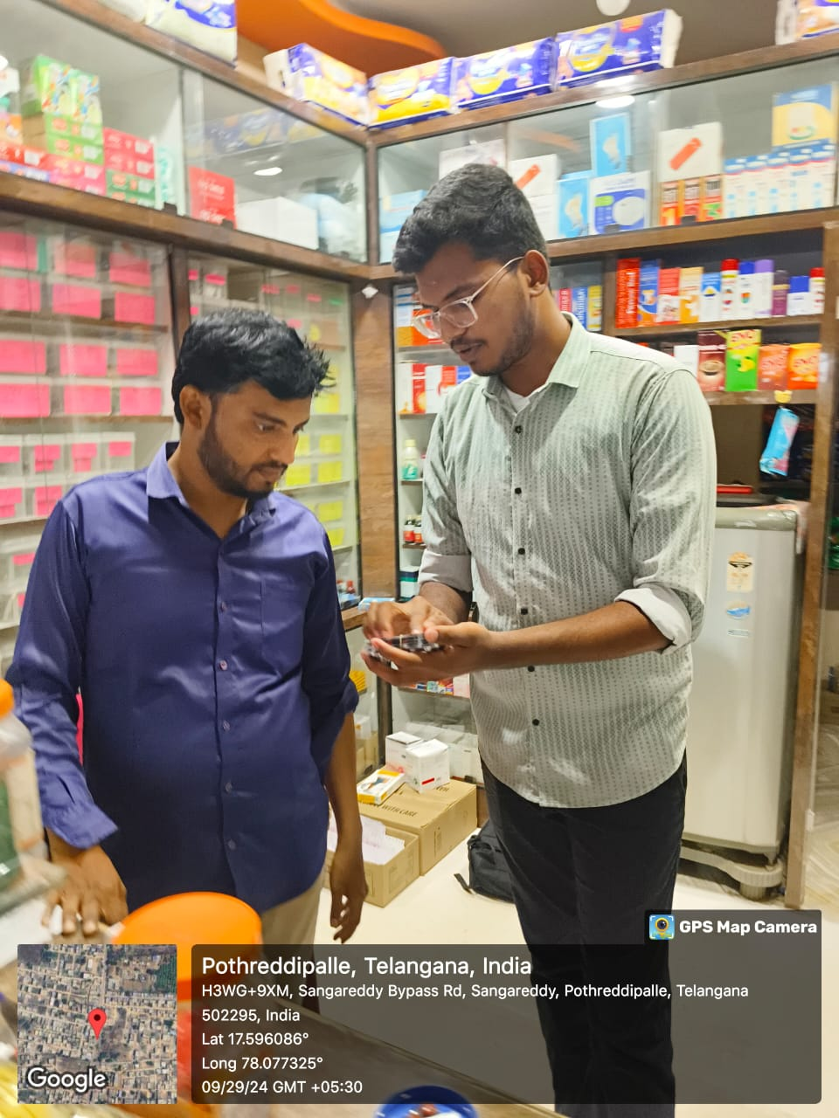

**Objective:**

On Day 2, I went to the chemist again to present the basic model of the Medication Recommendation System and gather feedback for potential improvements but due to different shifts different person was avilable.

# Questions Discussed:

1. **How well does the current model address common prescription needs?**
   * **Answer:** The model addresses basic needs but could benefit from including more specialized medications for rare conditions and

accounting for drug availability in local pharmacies.

# What improvements would you suggest for drug interaction warnings?

* + **Answer:** The model should include more comprehensive warnings for both common and less-known drug interactions, especially for over-the-counter combinations.

# How accurate are the dosage recommendations in the model?

* + **Answer:** Dosages are generally accurate but could be improved by considering factors such as patient weight, age, and organ function for more personalized recommendations.

# Does the model cover sufficient over-the-counter (OTC) options?

* + **Answer:** The model needs to expand its range of OTC

medications, particularly for mild conditions, while ensuring clear guidelines to prevent misuse.

# How can the model better address polypharmacy scenarios?

* + **Answer:** Adding a feature to flag potential polypharmacy cases (patients taking multiple medications) with a suggestion to consult a pharmacist or doctor would be beneficial.

# Are the dietary and lifestyle recommendations aligned with common practices?

* + **Answer:** The dietary suggestions are good, but adding more

condition-specific dietary restrictions and exercise routines would make the model more practical.

# What improvements can be made for pediatric and elderly prescriptions?

* + **Answer:** The model should include more age-specific adjustments, particularly for pediatric dosages and elderly patients with multiple conditions.

# How could the user interface be improved for chemists?

* + **Answer:** A more intuitive interface with easy access to common prescriptions and a clearer drug interaction section would improve usability.

# Is there enough focus on medication adherence strategies?

* + **Answer:** The model could provide more reminders and tips to

enhance patient adherence to medication schedules, especially for long-term treatments.

# What additional features would make the model more useful in practice?

* **Answer:** Adding a feature to track patient allergies and updating the system regularly with the latest drug approvals would be valuable.

# Key Insights:

The chemist provided valuable feedback to enhance drug interaction

warnings, improve dosage accuracy based on individual factors, and add

more practical features for polypharmacy, age-specific prescriptions, and medication adherence strategies.

# Day 3: Meeting with Doctor and chemist

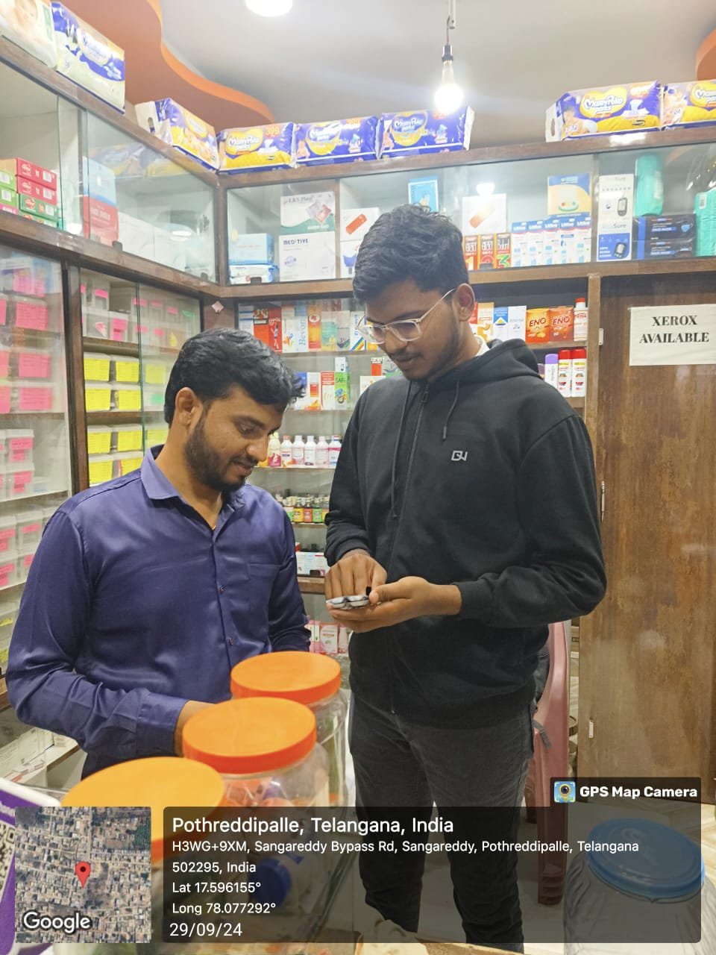

**Objective:**

Since the chemist was unavailable, I met with a doctor to gather information regarding symptom-to-disease diagnosis, treatment planning, and patient care strategies.

# Questions Discussed:

1. How do you approach diagnosing a disease based on limited symptoms?
2. What are the most common symptoms you encounter in your practice?
3. How do you prioritize treatment when multiple symptoms indicate different diseases?
4. What is your process for prescribing medications based on symptoms alone?
5. How do you track patient recovery and medication effectiveness?
6. What are the challenges in recommending generic vs. brand-name medications?
7. How do you manage patients with allergies to certain drugs?
8. What role do dietary plans play in treatment alongside medication?
9. How often do you suggest lifestyle changes (exercise, diet) over medication?
10. What are the typical follow-up steps after prescribing a new medication?

Summarized Answer: -

# Diagnosing with limited symptoms:

A systematic approach is used, starting with the most common conditions associated with the symptoms and using patient history and diagnostic tests to confirm.

# Common symptoms encountered:

Common symptoms include fever, cough, fatigue, headaches, and digestive issues, which often indicate a wide range of conditions.

# Prioritizing treatment for multiple symptoms:

Focus is given to life-threatening conditions first, followed by addressing the most distressing symptoms or those causing complications.

# Prescribing medications based on symptoms alone:

When a diagnosis is unclear, I prescribe broad-spectrum or symptomatic treatments while waiting for diagnostic results, ensuring the patient is closely monitored.

# Tracking patient recovery and medication effectiveness:

Regular follow-ups, patient self-reports, and lab results are key to monitoring recovery and adjusting treatment as needed.

**Challenges with generic vs. brand-name medications:** Patients may perceive generics as less effective, though they are bioequivalent. Cost differences also play a role in preference.

# Managing drug allergies:

A detailed patient history is crucial. I avoid prescribing medications with known allergens and use alternatives whenever possible.

# Dietary plans in treatment:

Diet is integral, especially for chronic conditions like diabetes or heart

disease. I often recommend tailored dietary changes alongside medications.

# Suggesting lifestyle changes over medication:

For mild conditions or chronic disease management, lifestyle changes such as improved diet, exercise, and stress reduction are often prioritized.

# Follow-up steps after prescribing a new medication:

Typically, I schedule a follow-up after a week or two to check for side effects, effectiveness, and to adjust the dosage if necessary.

# Day 4: Meeting with Chemist (Final Model Presentation)

**Objective:**

On Day 4, I met with the same chemist to present the final version of the Medication Recommendation System, incorporating feedback from previous meetings. The goal was to review the improvements made and gather final suggestions before deployment.

# Questions Discussed:

1. **How does the final model compare to the initial version in terms of usability?**
   * **Answer:** The final model is significantly more user-friendly, with an improved interface that allows for quicker access to key information, making it easier for chemists to navigate.

# Are the drug interaction warnings now comprehensive enough?

* + **Answer:** The updated interaction warnings cover a broader range of drugs and are more detailed. This addition is a major

improvement, especially in preventing common yet overlooked interactions.

# Has the dosage accuracy improved with the new personalized factors?

* + **Answer:** The dosage recommendations are now more tailored,

taking into account individual patient factors like age, weight, and organ function, making them more reliable and effective.

# Is the expanded OTC medication list sufficient?

* + **Answer:** The inclusion of more OTC medications makes the model more practical for everyday use, especially for treating mild

conditions and managing self-care.

# Does the polypharmacy flagging feature meet practical needs?

* + **Answer:** The polypharmacy feature works well, alerting chemists when a patient is prescribed multiple medications that could

interact, prompting further review or consultation.

# Are the pediatric and elderly prescription adjustments satisfactory?

* + **Answer:** The model now effectively adjusts dosages for both pediatric and elderly patients, ensuring safety for these more vulnerable groups.

# How do you feel about the dietary and lifestyle recommendations?

* + **Answer:** The enhanced dietary and lifestyle recommendations are more specific and condition-oriented, adding real value to the system by promoting a holistic approach to treatment.

# Is the medication adherence support sufficient?

* + **Answer:** The model’s reminders and tips for ensuring medication adherence are helpful, especially for patients on long-term

medications.

# Do you think the allergy-tracking feature will improve patient safety?

* + **Answer:** The allergy-tracking feature is a crucial addition, helping to prevent allergic reactions by automatically flagging medications that could cause issues based on a patient’s history.

# Would you suggest any further improvements before full implementation?

* **Answer:** The model is robust, but regularly updating the drug database and adding more real-time tracking features for patient outcomes would make it even better.

# Key Insights:

The chemist confirmed that the final model addresses previous concerns, with improved usability, detailed drug interaction warnings, and personalized dosage recommendations. The additional features such as polypharmacy flagging, adherence support, and allergy tracking significantly enhance the system’s practicality and safety.